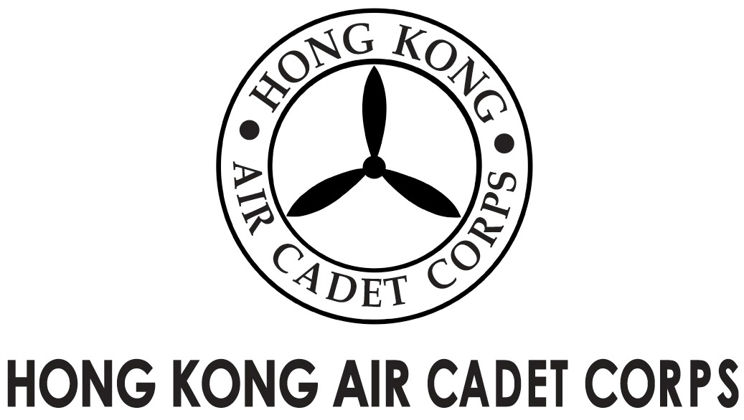
ADMINISTRATION AND SUPPORT GROUP.

From | Adjt A&S Gp / OC PA Flt  (michael@etoileam.com) | To | All major unit commanders
Our Ref | AwardsDay/2015/2 | # of Pages | 1
Date | 2/2/2015 | Your Ref

HKACC Awards Day 2015 – Change of Date

Referring to the previous circular (Ref: AwardsDay/2015/1; HQ msg 014/15), the date of the Awards Day 2015 has been rescheduled to 8/3/2015 (Sunday) 1500 hrs due to a lately confirmed overseas trip for the senior management. The Awards Day will be held at Gotfried Room, Aviation club. Further details will be disseminated once confirmed.

Thank you very much for your attention.

(signed on original)

Flt Lt Michael CHAN
Adjt A&S Gp / OC PA Flt

